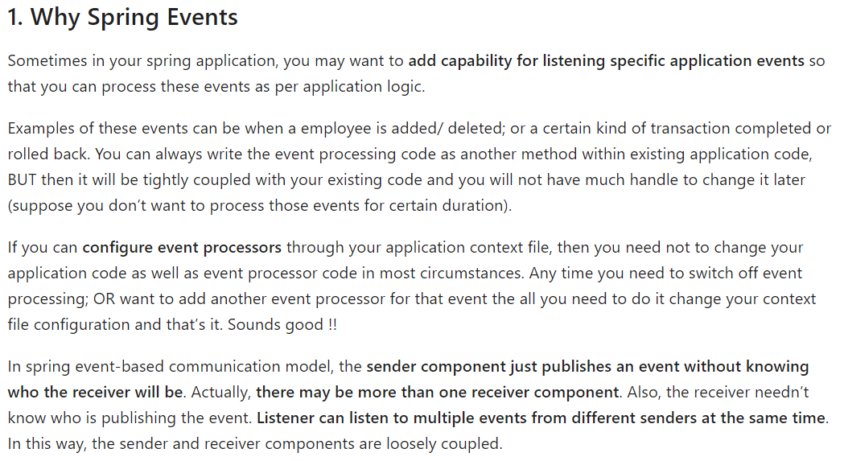

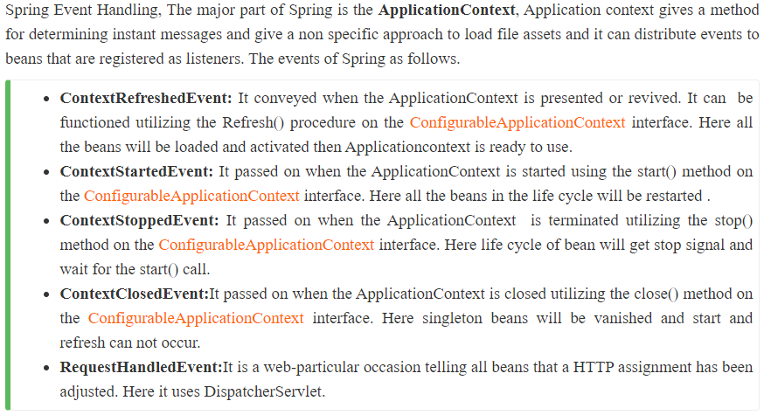

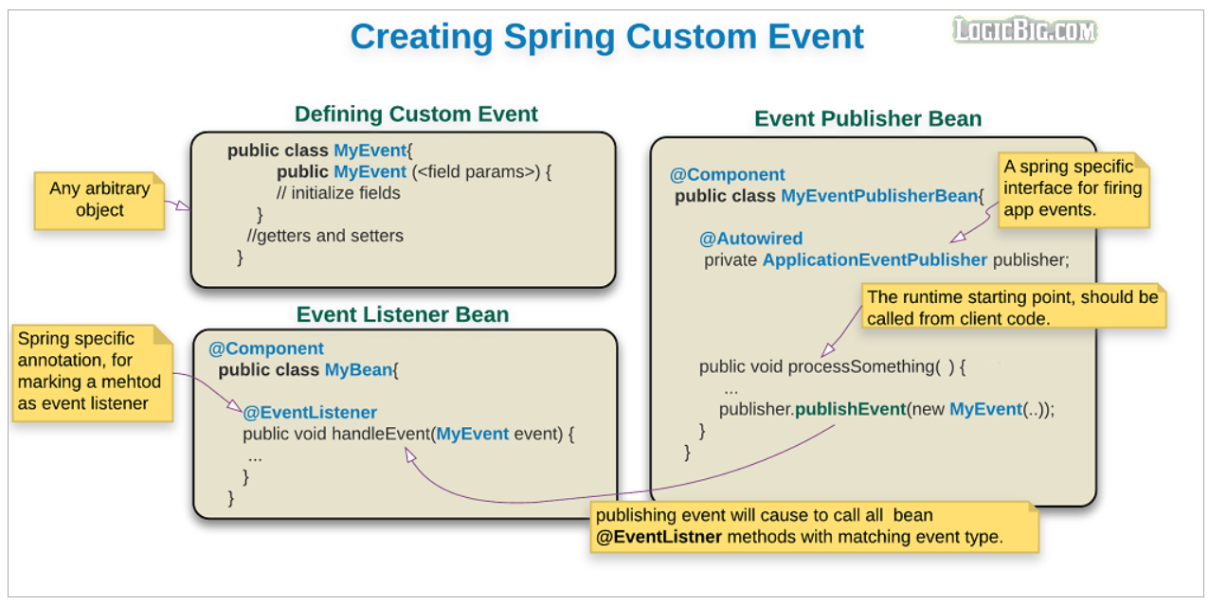  
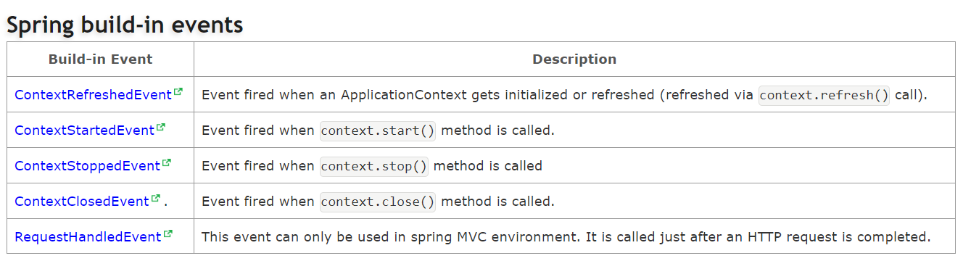  
  
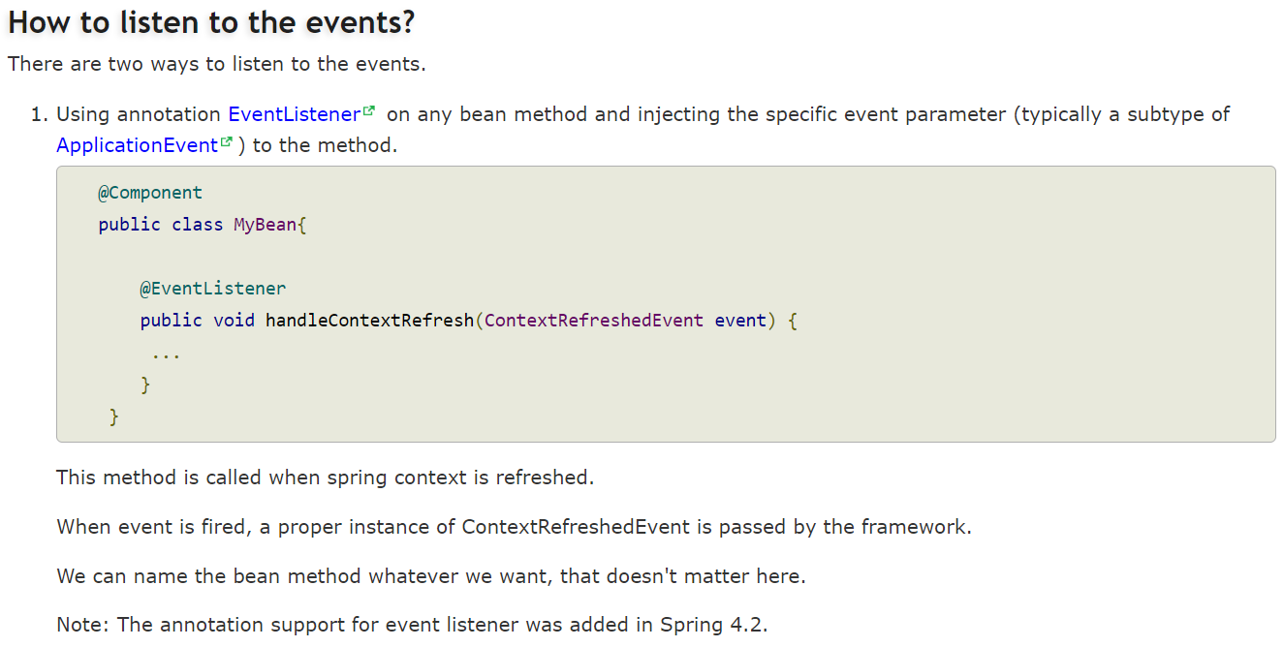

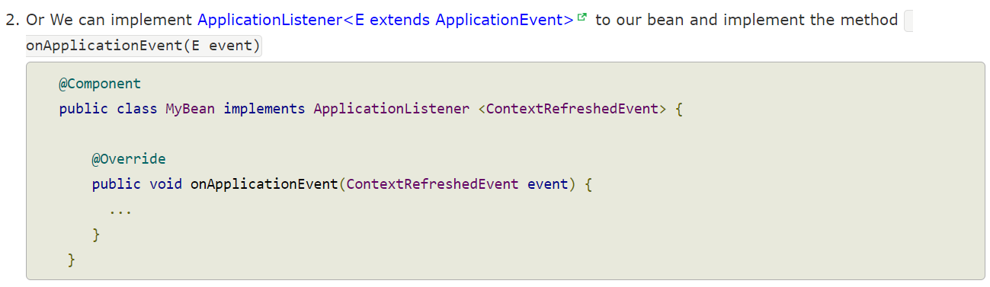

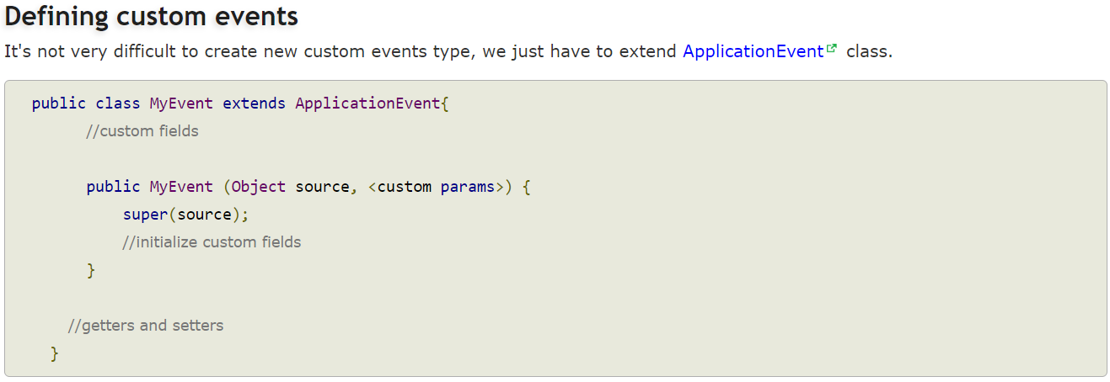

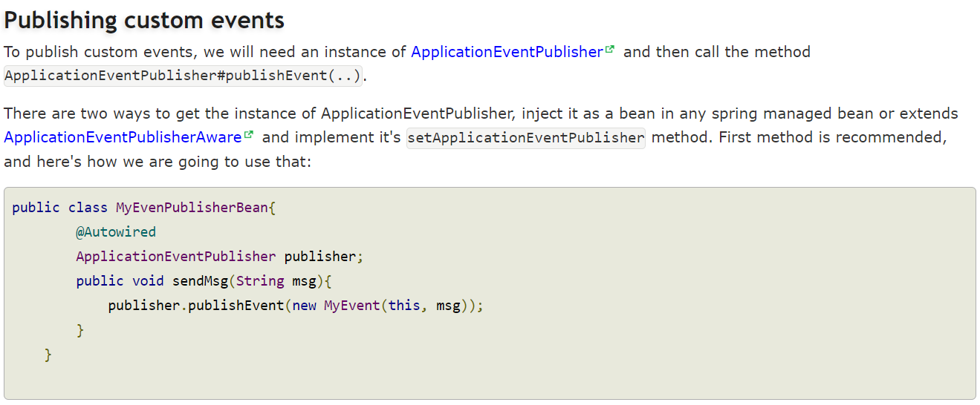

**Custom Events:**

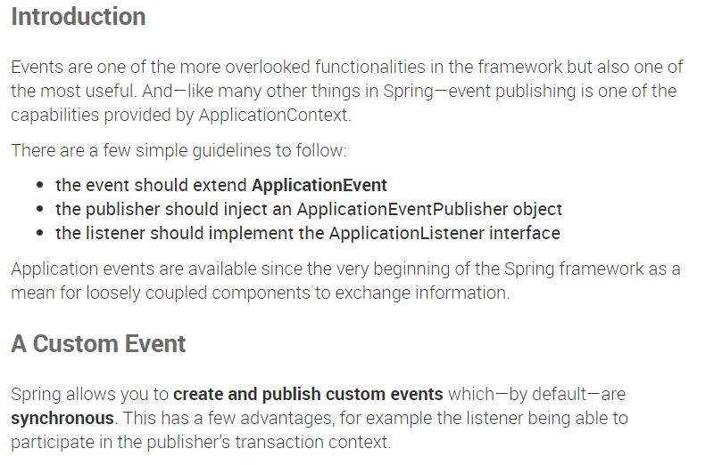  
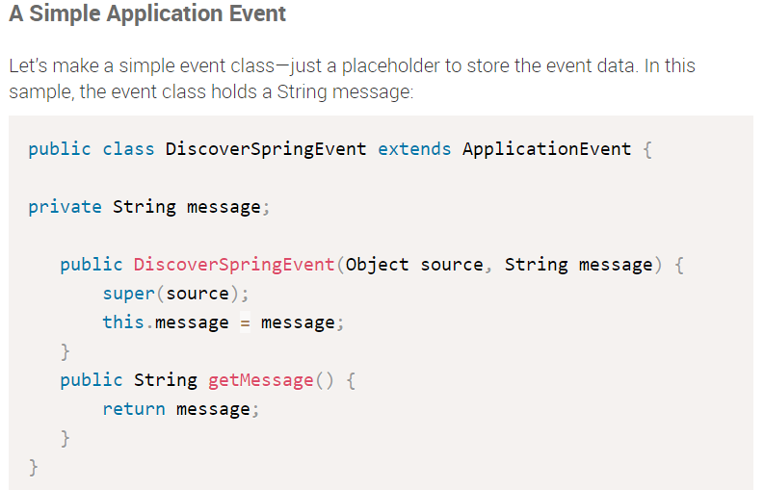

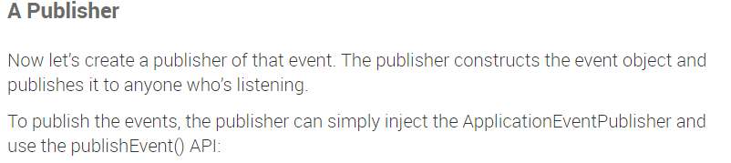

public class DiscoverSpringEventPublisher {

@Autowired

private ApplicationEventPublisher applicationEventPublisher;

public void doStuffAndPublishAnEvent(final String message) {

System.out.println("Publishing custom event. ");

DiscoverSpringEvent discoverSpringEvent = new DiscoverSpringEvent(this, message);

applicationEventPublisher.publishEvent(discoverSpringEvent);

}

}

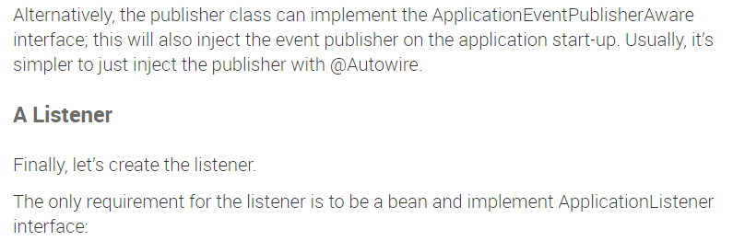

@Component

public class DiscoverSpringEventListener implements ApplicationListener<DiscoverSpringEvent> {

@Override

public void onApplicationEvent(DiscoverSpringEvent event) {

System.out.println("Received spring custom event - " + event.getMessage());

}

}

